**Use Cases**

|  |  |
| --- | --- |
| **Use Case** | **Requirements covered** |
| Manage a blog | 1, 2, 4, 5, 6, 11 |
| Manage a post | 1, 2, 3, 4, 5, 7, 8, 10 |
| Search a post | 1, 4, 5 |
| Comment a post | 1, 9, 12, 13, 14 |

**Use Case Diagram**

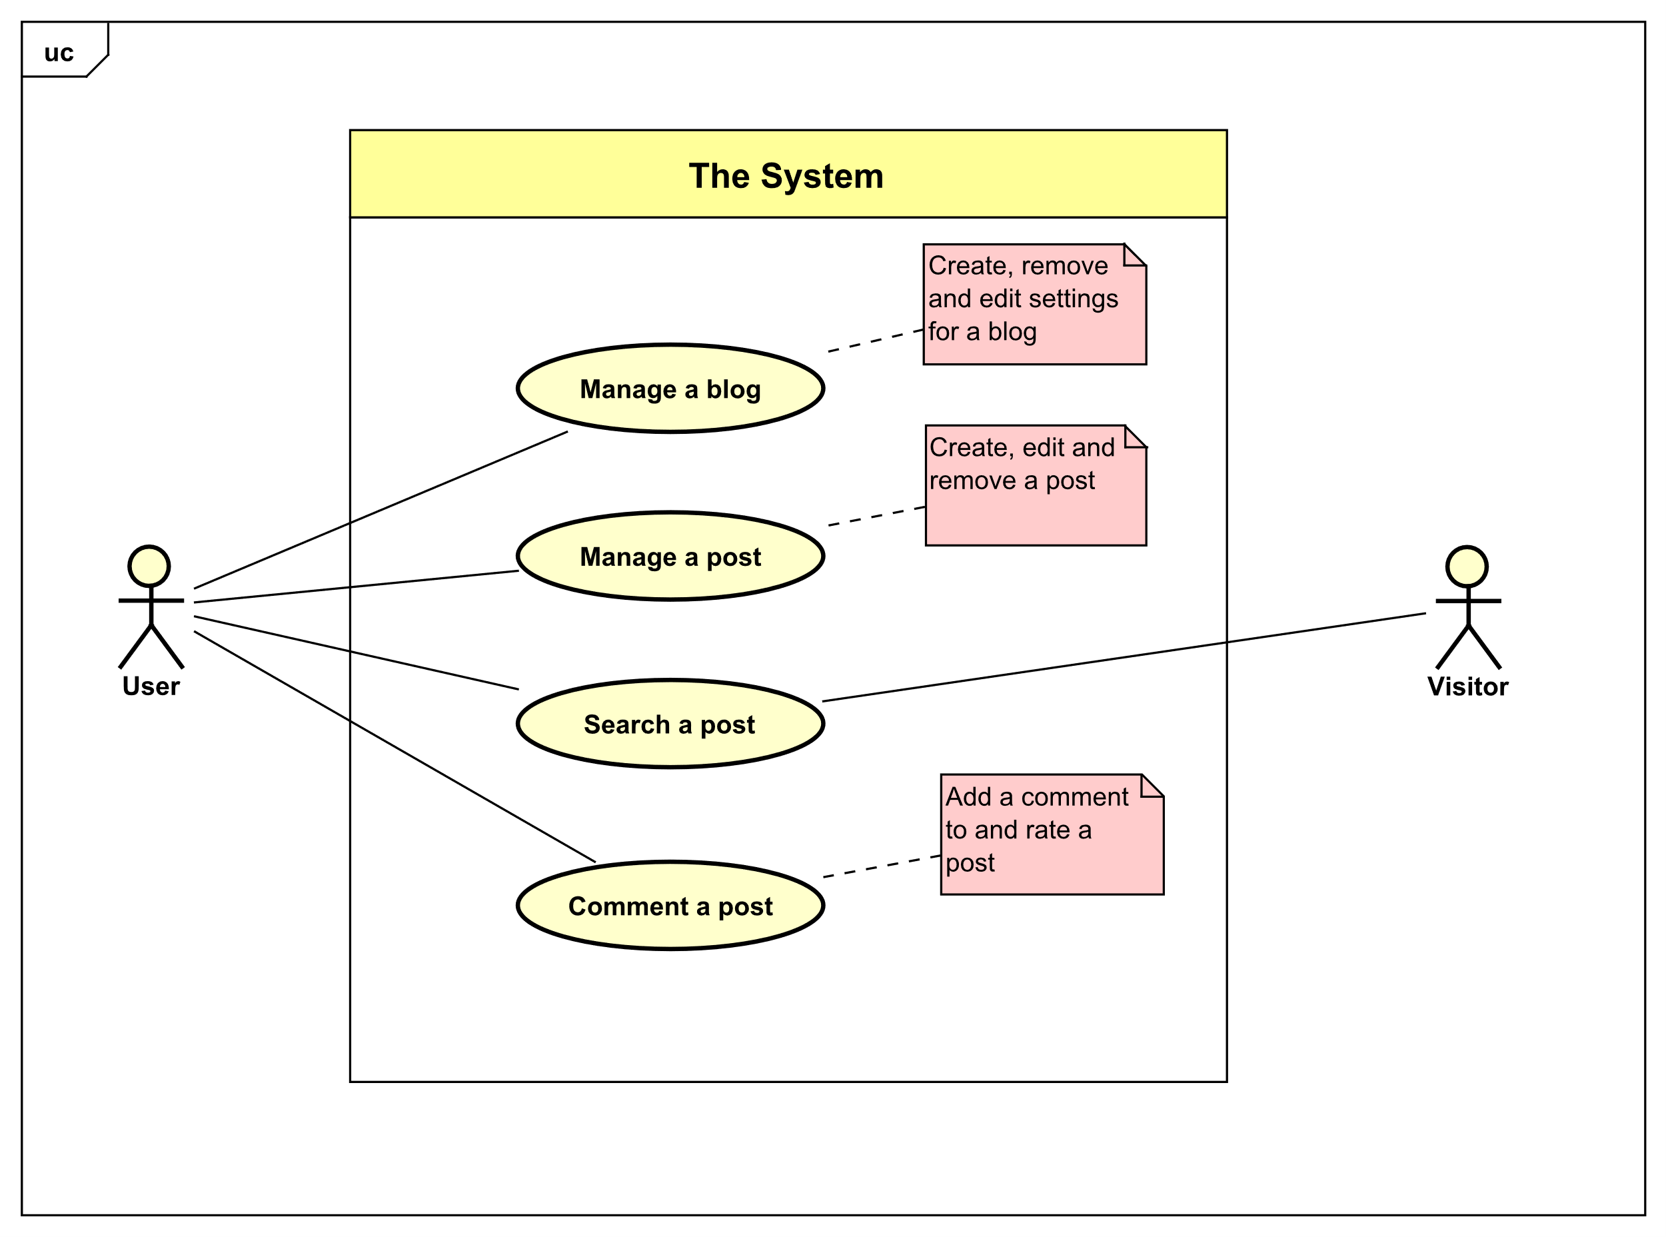

**Use Cases – Brief Description**

**Manage a Blog** – A user decides to start a new blog. They log into their account, navigate to their blog list and select create blog option. There they enter a name of the blog. Then they select a category or multiple categories that the blog will focus on. They also have an option to use keywords to make it easier for other users to find their blog. After that they select create option and their blog is created. If they choose to remove their blog, they navigate go to settings and select the blog they want to remove and select remove option.

**Manage a Post** – A user decides to add a new post into their blog. They log into their account, navigate to their blog list and select the blog they want to add the new post to. After that they select create post option. There they specify the name of the post, the categories/keywords it covers and the content of the post itself. If the user decides to, they can delete one or multiple posts from the blog.

**Search a post** – A user decides to search for a blog post of another user. They enter the keyword / name of the post into the search field and select search option. A list of posts that contain these keywords or post name is shown and the user can filter this list by popularity, views or date of post. After that the user selects the post they want to read and the content of the post is shown.

**Comment a post –** A user decides to comment or like/dislike the post they just read. The user navigates to the bottom of the post or the comment and there they are two options: to like or to dislike. The user can select either of those options to express their opinion about the post/comment. If they want to comment, they can do so by navigating to the comment section in the bottom of the post and select comment option. For responding to other comments, there is a comment option on the right corner of the comment.

**Uses Cases – Fully Dressed Description**

|  |  |
| --- | --- |
| **Use Case** | Manage a Blog |
| **Summary** | A user creates or deletes a blog |
| **Actor** | User |
| **Precondition** | A user is logged in |
| **Postcondition** | A blog is created or deleted |
| **Base Sequence** | CREATE A BLOG   1. A user selects “Blog list” option 2. The System shows a list of all the blogs created by the user 3. A user selects “Create a blog” option 4. The system prompts the user for the name, category and keywords for the blog 5. The user enters the information prompted in the step above 6. The user selects “Create” option 7. A new blog is added to the system   DELETE A BLOG   1. A user selects “Blog list” option 2. The System shows a list of all the blogs created by the user 3. A user selects one of the blogs 4. The system shows information and options to manage the blog 5. The user selects “Delete blog” option 6. A blog is deleted from the system |
| **Branch Sequence** |  |
| **Exception Sequence** | Step 7   * If the user enters a name of a blog that exists in the system, it will show an error message and not proceed with the operation |